

INDIVIDUAL ASSIGNMENT

LANKA

COMP40004

**WEB DEVELOPMENT AND OPERATING SYSTEMS-1**

**CF23A1COM**

HAND OUT DATE: 2nd week

HAND IN DATE: ASSIGNMENT2: 19th Jan 2024

WEIGHTAGE: ASSIGNMENT 2: 30%

**INSTRUCTION TO CANDIDATES:**

1. **Students are advised to underpin their answers with the use of references (cited using the Harvard Name System of Referencing).**
2. **Late submission will be awarded zero (0) unless Extenuating Circumstances (EC) are upheld.**
3. **Cases of plagiarism will be penalized**
4. **Assignment presentation should be submitted in the form of softcopy and hardcopy both; modeling work should be submitted in softcopy form**

**Wire frame**

**Homepage**

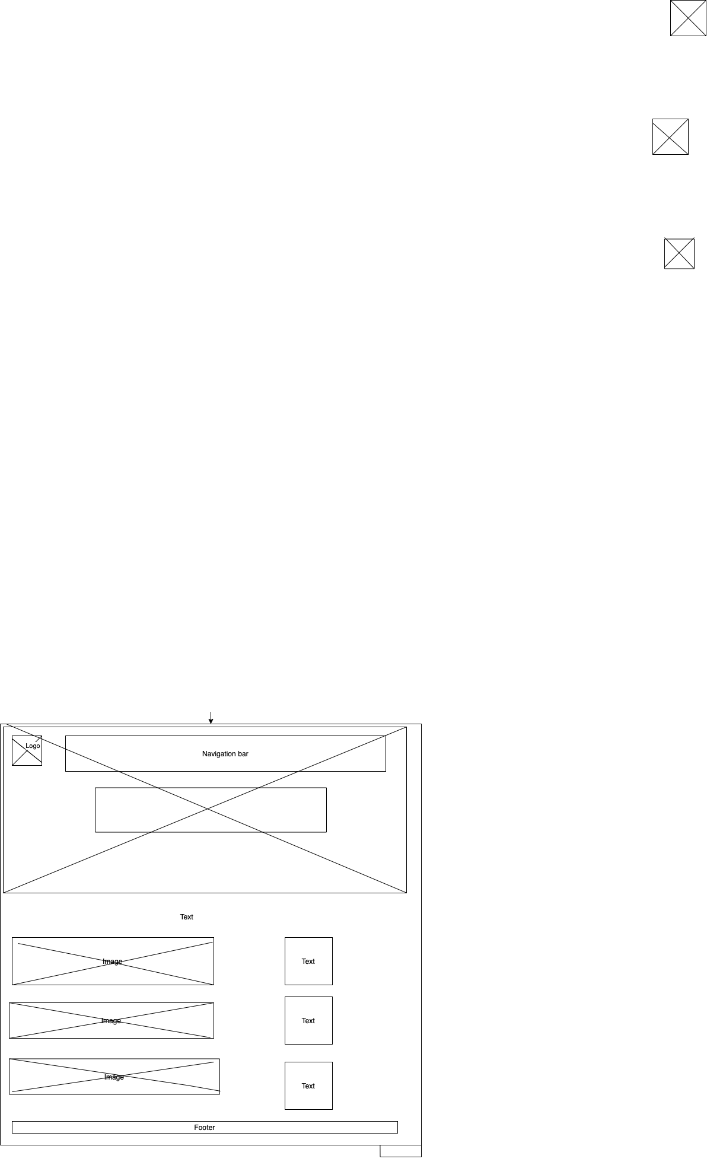

**Introduction of wildlife**

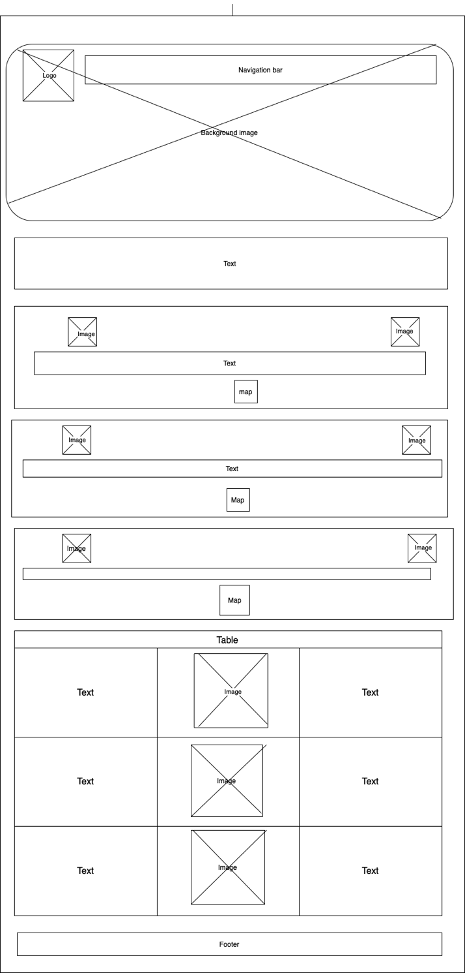

**Department of Wildlife Conservation**

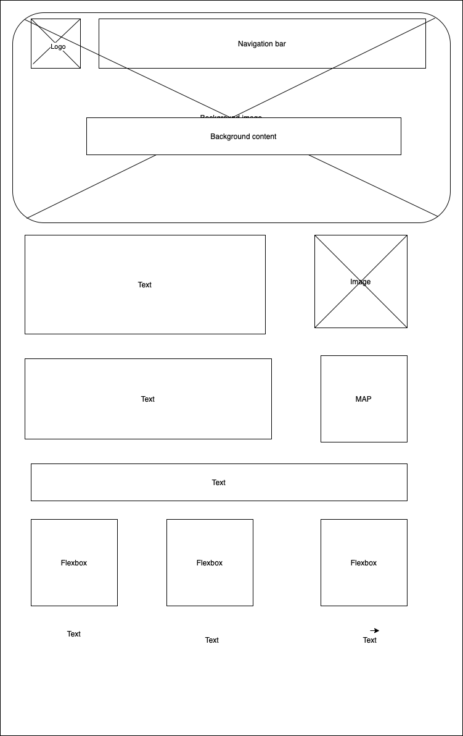

**About Sri Lankan Leopard**

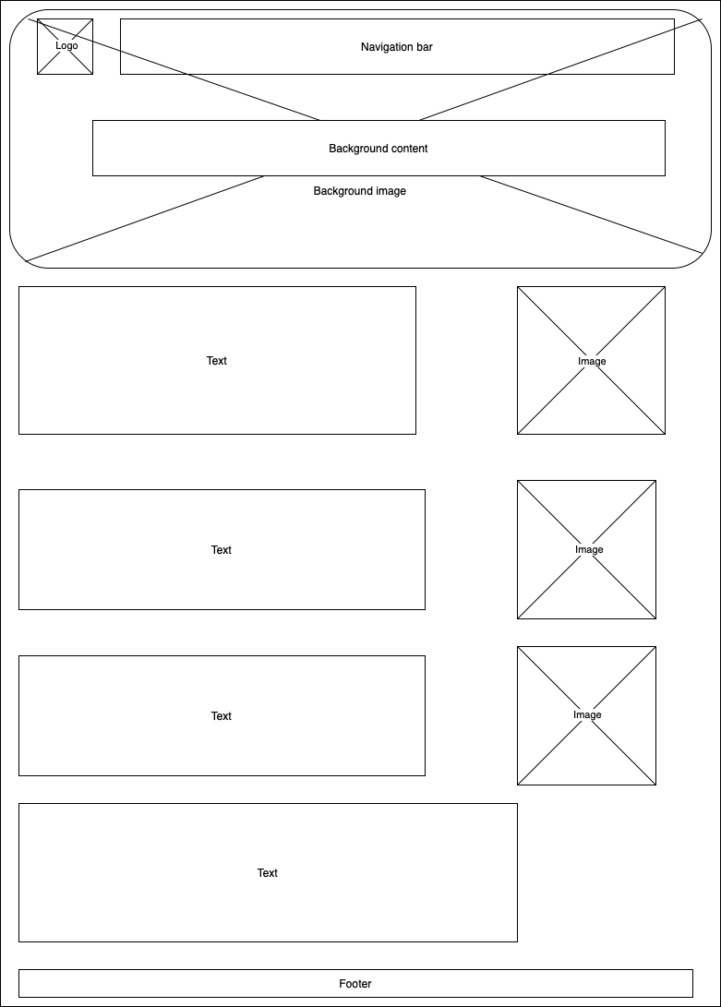

**Information about Sri Lankan animal**

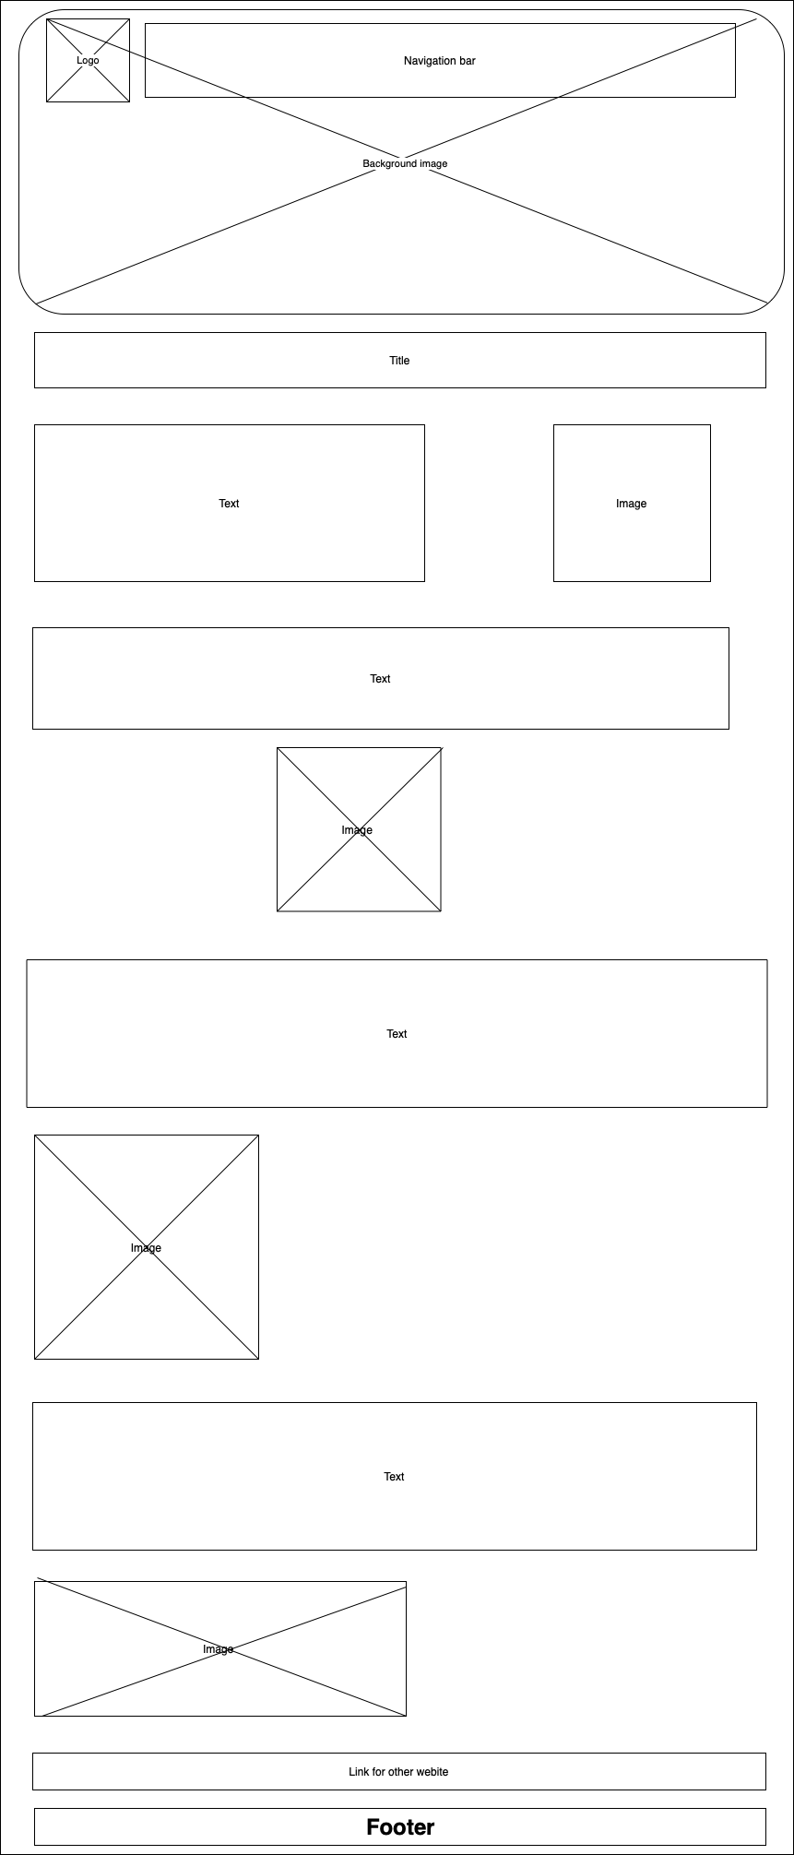

**Yala page**

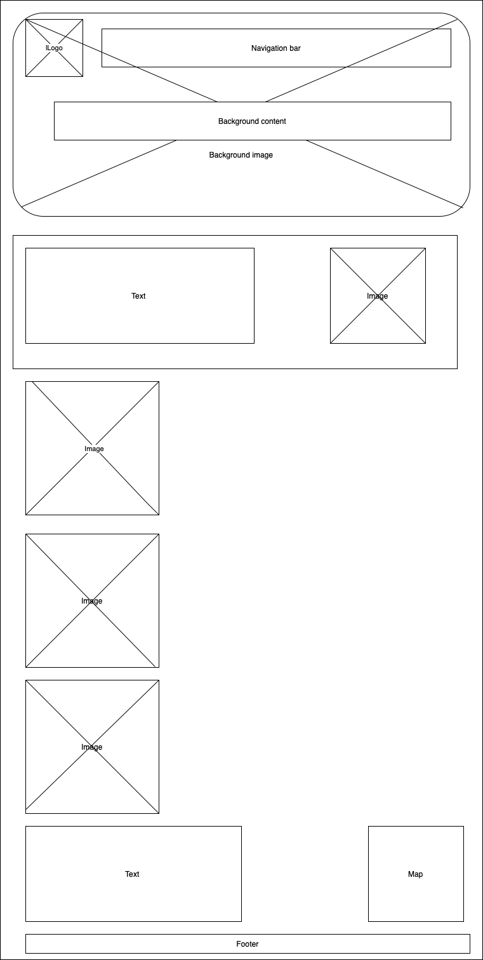

**Wilpathu page**

